**RReport Implementation Plan**

**Create Pittsburgh Report Sub Menu Reports with two sub menus**

1. **Lit Log Sheet/Claim Evaluation/Ad hoc Report**
2. **Cause Code Summary Report**

**Whether this functionality is used only for Litigation Matter or all the cases like Claim,Contract,litigation,general?**

# **Lit Log Sheet/Claim Evaluation/Ad hoc Report**

## Develop a search screen with below search fields

1. File Number
2. Category
3. Type
4. Attorney
5. Subject
6. Team
7. Staff
8. Court
9. Court Number
10. Cause (new Field-Its coming from Litigation_matter_table). **Needs to know datatype ? picklist or text)**
11. Department
12. Acct
13. Disposition
14. **OS Csnl – (Note * need to know what this field is ?)**
15. **Judge**
16. **Date Ranges for** 
    1. **Date Opened**
    2. **Incident**
    3. **Filed**
    4. **Served**
    5. **Assigned**
    6. **Review - ?**
    7. **Disposition**
    8. **Status**
    9. **(Need to check with client if they need all fields? Or we need to drop any fields in search)**

**Where the data is coming from for Team,Subject,Staff,Department,Acct and Review Rate?**

## **Once Search performed**

* 1. Display the search results in grid with below column.
     1. File #, Case Name, Date Opened, Date Filed, Incident Date, Date Served, Type, Category, Subject, Cause, Team and Attorney.
  2. Provide three buttons for each report types
     1. Litigation Log Sheets
     2. Claims Evaluation Sheet
     3. Ad hoc Report

## **Litigation Log Sheets**

* + 1. **Once User clicks Print Litigation Log Sheet**, system will use the selected case/s
    2. System will displays below screen to select fields to be displayed on the report
       1. 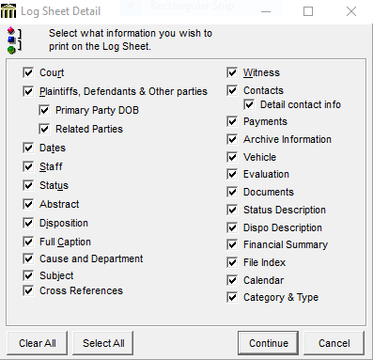

Note * we need information on fields like:

1. Cause and Department, Cross Reference, Payments, Archive Information, Evaluation, Status Description,Dispo Description,Financial Summary,Calendar

2.Plaintiff means Opposing Counsel?

3. Other Parties : Where the data is coming from ? is that Other case pariticipants or all participants?

4. Primary parties and Related parties ?

4. Contacts -whose contact?

* + 1. We need complete sample pdf for above report.
    2. On Continue system will generate Litigation Log Sheet

**Litigation Log Sheet Sample report**

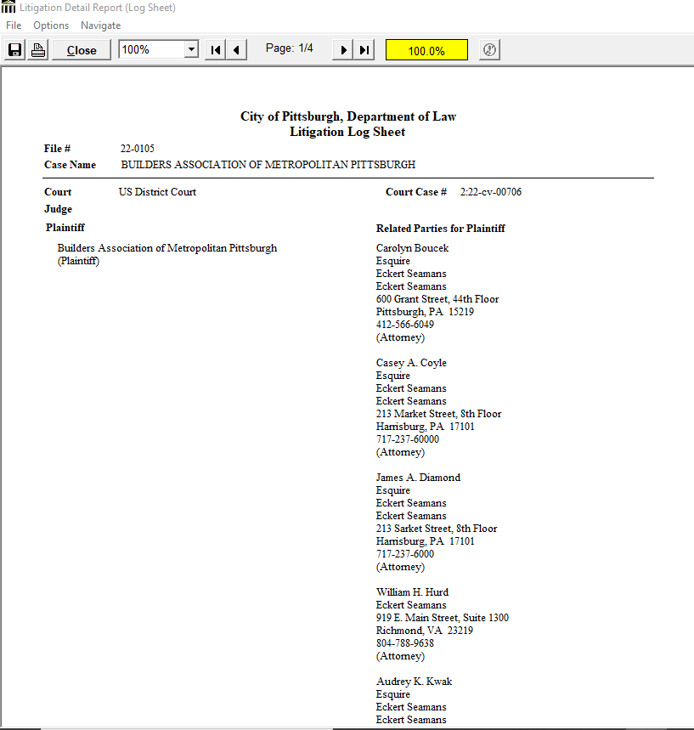

## **Claim Evaluation**

1. **Once user clicks on Claims Evaluation button** system will use the selected case/s
2. System will display below screen to select fields to be displayed on the report



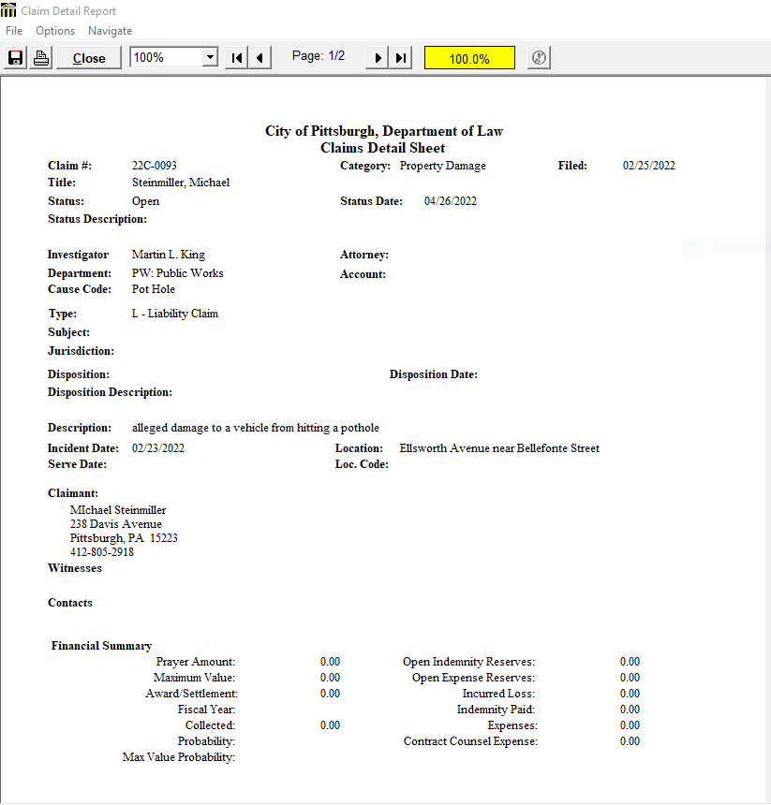­­

Needs to know all Financial Fields mentioned above in the image?

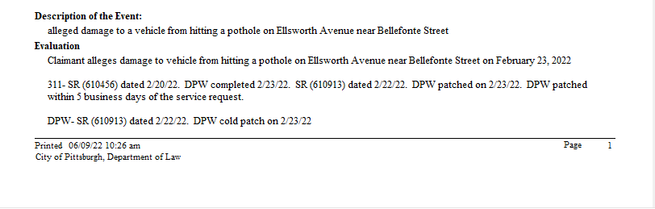

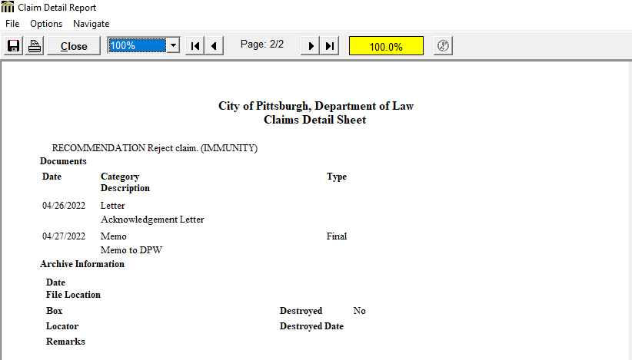

## **Ad hoc Report – Custom List**

1. **Once user clicks on Claims Evaluation button**
2. System displays the custom Litigation List screen and it allows user to select the required fields to be exported to excel
3. E.g For this sample the following fields were selected for the report: File #, File Name, Filed Date, Court, Court Number, Cause Description, Disposition [if any], Disposition date [if any] and Settlement (or Judgment) amount [if any]. A Landscape Report to print in descending File # order, as and the report will generate in the form of an Excel Spreadsheet

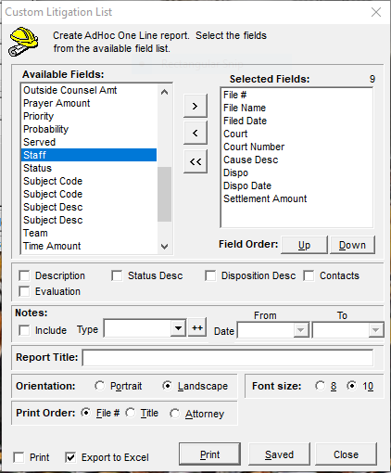

Needs to know what are all fields will display on “ Available fields” section? And where

The data’s is coming for all those fields ?

1. The Excel Report will then generate as follows after ‘print’ is selected

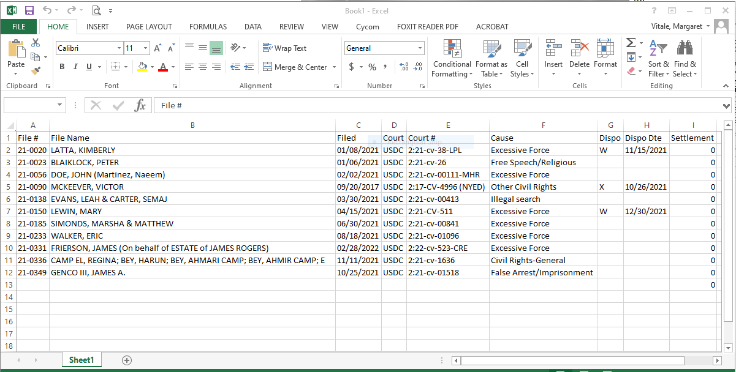

# **Cause Code Summary Report**

Monthly and quarterly report used to send to City Council providing the number of claims received (by claim type and department involved and the amount approved for payment [if applicable].

Once click on the menu, system should display search criteria screen.

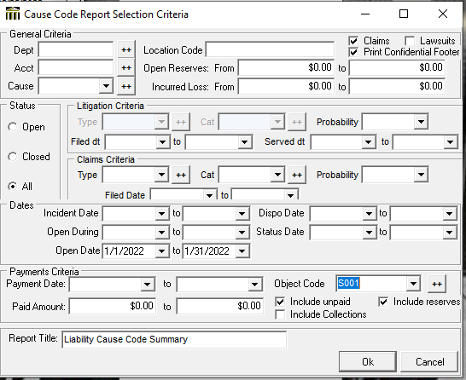

Note* Not sure if they need all search options or just, Open Date Range, Status.

Needs to know where the data’s is coming from for all fields?

After the Criteria are selected, OK is selected to generate the report

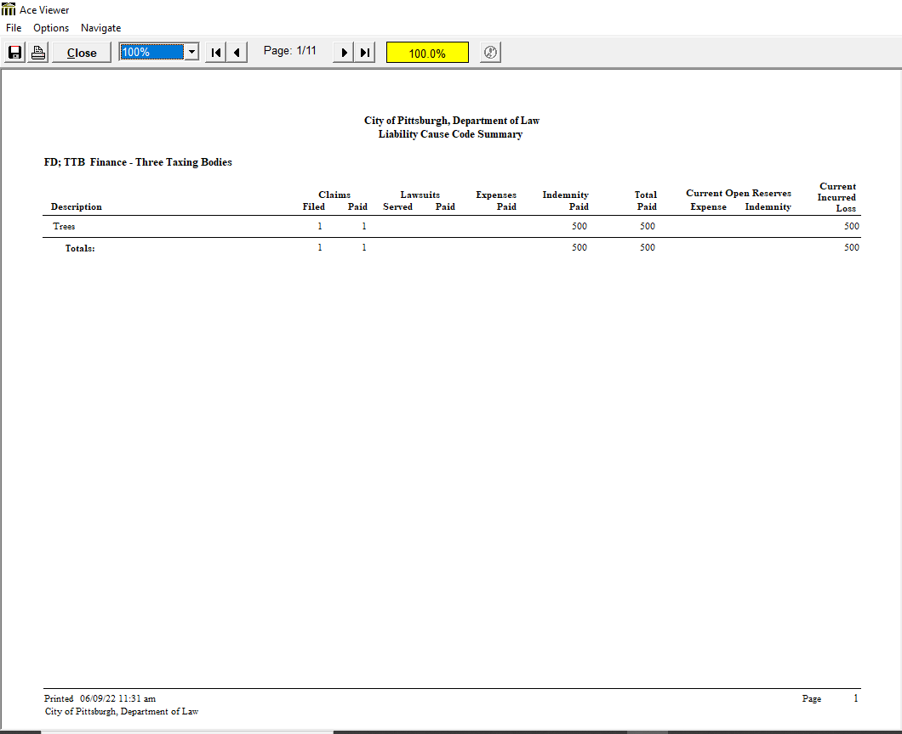

**1.In above image , where the data is coming from for Description,Claims(Filed,Paid), Lawsuits, expenses, Indemnity paid,total paid,Current expense, Reserve Indemnity,Current incurred loss.?**

**Estimation**

|  |  |  |
| --- | --- | --- |
| **Sl No** | **Description** | **Hours** |
| 1 | Developing Ad hoc search screen | 24 |
| 2 | Litigation Log sheet | 24 |
| 3 | Claims Evaluation Sheet | 24 |
| 4 | Ad hoc Report – Exporting to excel | 24 |
| 5 | Cause Code Summary Report | 24 |
| 6 | Clarification or Analysis | 16 |
| 7 | Testing | 16 |
|  | **Total** | **128** |